Viatronix V3D CAD Processor API 1.0

Introduction

The V3D CAD Processor API (“API”) allows CAD vendors to integrate their specific solutions within the Viatronix processor workflow. The API is an automation enabled COM library allowing for a wide range of languages and environments to consume it.

The API presents a “plugin” based framework in which there is a processor that dynamically loads vendor supplied plugins to perform CAD processing. The API provides the following to a plugin:

- Intensity Volumetric Data
- Mask Volumetric Data (e.g., for the segmented colon)
- DICOM directory
- Logging Mechanism

In return the plugin provides a list of possible findings that can be verified within the V3D-Viewer.

API Overview

The API defines and IPlugin interface which defines one function Run() which must be implemented. See Figure below. You will get the Processor object and from there you have access to the volume data (through the Environment), access to the original DICOM data, use of the Viatronix logging mechanism, and a means to output the CAD findings through the Findings object.

The CAD vendor should:

- Define an application ID (COM ProgID)
- Implement the Run() function
    - Obtain the volume data
    - Populate the Findings object
- Provide Viatronix with an installer and uninstaller
- Provide Viatronix with 30 test cases (original DICOM data and expected results)

To assist implementation, Viatronix has provided two sample projects for Visual Studio 6 and Visual Studio 2003. It is advised to use these as a starting point for your own plugin. Make sure to change the program ID, co-class GUID, and type library GUID as indicated by the comments.

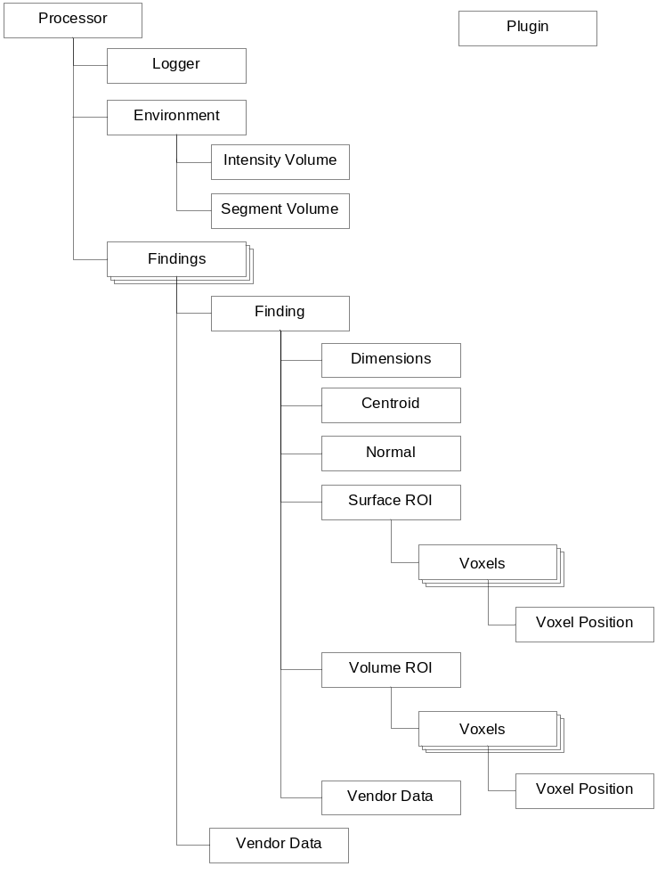
Figure 1 - API object model

API Details

It is required that the CAD vendor name and API version properties be properly supplied to the Findings object so that regulatory requirements are met.

The centroid is the only necessary piece of information required for each finding. The volume ROI is inteneded to contain a list of voxels that comprise the finding. The surface ROI should contain only those voxels that are normally visible from the outside; this can be used to color a finding in 3D. The normal is useful in determining the orientation of a finding; this can be used to help orient the view of the finding in 3D. The dimensions can be used to supply estimates of the size in three principal directions. The vendor data can be used to supply extra information that does not fit into the existing object categories.

The volume data is a simple linear array of HU values composed of signed integers. The interface also provides dimension and units information.

The mask data is only currently available for the colon. It is a linear array of unsigned bytes where zero corresponds to outside the colon, one to the first connected air-filled colon segment, two to the second, etc. There are normally not more than 30 or so segments.

To access the volume data, it is preferable to use the Viatronix interface because it provides an in-memory copy of the HU values without having to implement your own DICOM reading and conversion. This saves disk I/O time since Viatronix stores the data in a compressed format. Try to only access the volume data once during processing because each access makes a new copy of the volume in memory.

Alternatively, you can directly access the directory containing all the DICOM images, but note that the findings coordinate system must always conform to the following convention:
The origin is always at the volume corner near the patient’s right toe.
The X-coordinate increases from right to left.
The Y-coordinate increases from anterior to posterior.
The Z-coordinate increases from inferior to superior.

To provide maximum utility for debugging and maintenance, it is advised to use the Viatronix logging mechanism. It provides five levels of logging – from debug to critical errors which can be adjusted in the field by service personnel.

It is preferable to provide an out-of-process COM server because it decouples our process from the plugin so that we can provide proper continuity and meta-information back upstream.

Testing

To process a dataset there are two steps: first convert the DICOM images into
Viatronix format, and then run the test application.

To Convert to Viatronix Format

- In the Convert folder, double click CreateVolume.exe.

- Select the path to the DICOM images with the [...] button; Select one DICOM image and it will fill in the seed file and the path fields.

- Select your desired output volume file path. The name should take the form ‘XXX.vol'

- Click 'Create Volume'.

To Test the CAD Application

- Run your installer which should register your COM server.

- Go to the Test folder and execute the command:

Viatronix.v3D.Processor.Plugins.CAD.exe -regserver

- Then execute the command:

Viatronix.v3D.Processor.Plugins.CAD.exe -dsroot <rootPath> -appid <ID>

Note that rootPath is the full path WITHOUT the trailing '.vol' and and the appid being what your plugin has defined.

